**LDR CONTROLLED LED USING ARDUINO**

**Introduction**

We all want our home appliances to be controlled automatically based on some conditions and that's called [Home automation](https://circuitdigest.com/home-automation-projects). Today we are going to control the light based of darkness outside, the light turns ON automatically when it is dark outside and turns off when it gets bright. For this, we need a light sensor to detect the light condition and some circuitry to control the Light sensor. It’s like [Dark and light Detector circuit](https://circuitdigest.com/electronic-circuits/dark-and-light-indicator) but this time we are using Arduino to get more control over light.

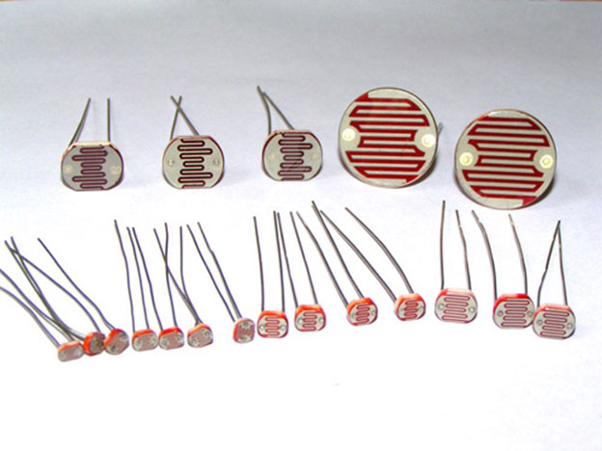**components**

* Arduino UNO
* LDR (Light Dependent Resistor)
* Resistor (100k-1;330ohm-1)
* LED - 1
* Connecting wires
* Breadboard

**Objective**

During this activity ,you will help students to achieve following objectives

1. Understanding the principle and operation of LDR
2. Design algorithm and flowchart to detect light in room
3. Programming LDR and LED using Arduino uno
4. Interfacing LDR and LED withArduino uno

**applictions**

1. The [Light Dependent Resistor (LDR)](http://www.polytechnichub.com/application-light-dependent-resistor-ldr/) used for automatic contrast and brightness control in television receivers.
2. The LDR is used in the infrared astronomy.
3. The LDR is used in optical coding.
4. Used in light activated control circuits.
5. Used in light failure alarm circuits and used in light meter.
6. The LDR used in smoke detectors.
7. Used in the security alarm.
8. The LDR also used in street light control circuits

**Programming steps**

1.first define pin for LED and LDR.

2. set led as output and ldr as input

3. read analog voltage value by A0 pin

4. If the value is less than 700 then it is dark and the LED or Light turns ON. If the value is greater than 700 then it is bright and the LED or light turns OFF.

**Programming**

int LED = 9;  
int LDR = A0;

void setup()   
{  
Serial.begin(9600);  
pinMode(LED, OUTPUT);  
  
pinMode(LDR, INPUT);  
}

void loop() {  
int LDRValue = analogRead(LDR);  
Serial.print("sensor = ");  
Serial.print(LDRValue);

if (LDRValue <=700)   
{  
digitalWrite(LED, HIGH);  
Serial.println("It's Dark Outside; Lights status: ON");  
}  
else   
{  
digitalWrite(LED, LOW);  
Serial.println("It's Bright Outside; Lights status: OFF");  
}  
}

**Hardware**

**Instructions**

* 1. **Connect positive end of LED to digital pin D9 and negative end to ground pon of Arduino**
  2. **Connect negative end of LDR to analog input pin A0 and positive end is to be connected to the VCC of Arduino.**
  3. **Make 220 ohm resistor connection in LDR such that in between GND and A0 pin.**
  4. **Make 220 ohm resistor connection in LED such that it connected to digital pin9**

